LIQUID CRYSTAL DISPLAY (LCD): -
LCD is a type of display used in digital watches and many portable computers. LCD displays utilize to sheets of polarizing material with a liquid crystal solution between them. An electric current passed through the liquid causes the crystals to align so that light cannot pass through them. LCD technology has advanced very rapidly since its initial inception over a decade ago for use in lap top computers. Technical achievements has resulted in brighter displace, higher resolutions, reduce response times and cheaper manufacturing process.
The liquid crystals can be manipulated through an applied electric voltage so that light is allowed to pass or is blocked. By carefully controlling where and what wavelength (color) of light is allowed to pass, the LCD monitor is able to display images. A backlight provides LCD monitor’s brightness.
Over the years many improvements have been made to LCD to help enhance resolution, image, sharpness and response times.
One of the latest such advancement is applied to glass during acts as switch allowing control of light at the pixel level, greatly improving LCD’s ability to display small-sized fonts and image clearly.
Other advances have allowed LCD’s to greatly reduce liquid crystal cell response times. Response time is basically the amount of time it takes for a pixel to “change colors”, in reality response time is the amount of time it takes a liquid crystal cell to go from being active to inactive.

This is due to following reasons:
The declining prices of LCDs.
The ability to display numbers, characters and graphics. This is in contrast to LEDs, which are limited to numbers and a few characters.
An intelligent LCD display of two lines, 20 characters per line that is interfaced to the pic16f72 microcontroller.
Incorporation of a refreshing controller into the LCD, thereby relieving the CPU to keep displaying the data. Ease of programming for characters and graphics.
Most of the LCD modules conform to a standard interface specification. A 14-pin access is provided having eight data lines, three control lines and three power lines. The connections are laid out in one of the two common configurations, either two rows of seven pins, or a single row of 14 pins.
One of these pins is numbered on the LCD’s printed circuit board (PCB), but if not, it is quite easy to locate pin1. Since this pin is connected to ground, it often has a thicker PCB track, connected to it, and it is generally connected to metal work at same point.
PIN DIAGRAM OF LCD: -
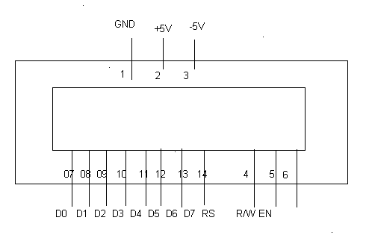

PIN DESCRIPTIONS: -
Vcc, Vss and Vee: -
While Vcc and Vss provide +5V and ground respectively, Vee is used for controlling LCD contrast.

RS Register Select: -
There are two very important registers inside the LCD. The RS pin is used for their selection as follows.
If RS=0, the instruction command code register is selected, allowing the user to send a command such as clear display, cursor at home, etc.
If RS=1, the data register is selected, allowing the user to send data to be displayed on the LCD.
R/W, read/write: -
R/W input allows the user to write information to the LCD or read information from it.
R/W = 1 for reading.
R/W= 0 for writing.
EN, enable: -
The LCD to latch information presented to its data pins uses the enable pin. When data is supplied to data pins, a high–to-low pulse must be applied to this pin in order for the LCD to latch in the data present at the data pins. This pulse must be a minimum of 450 ns wide.
D0 – D7: -
The 8–bit data pins, DO – D7, are used to send information to the LCD or read the contents of the LCD’s internal registers.
To display letters and numbers, we send ASCII codes for the letters A–Z, a-z numbers 0-9 to these pins while making RS=1.
There are also instruction command codes that can be sent to the LCD to clear the display or force the cursor to home position or blink the instruction command codes.
We also use RS = 0 to check the busy flag bit to see if the LCD is ready to receive information. The busy flag is D7 and can be read when R/W=1 and RS=0, as follows: if R/W = 1, RS = 0. When D7= 1 (busy flag = 1), the LCD is busy taking care of internal operations and will not accept any information.

